1. An 11-year-old boy presents to the clinic for evaluation of seizures. On examination, he has multiple hypopigmented lesions, as shown in the image below. What term best describes these lesions?

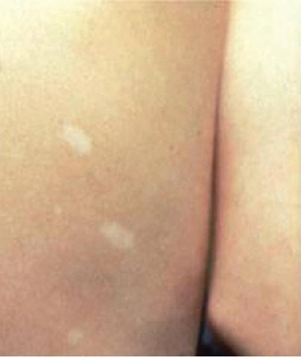

1. Ashleaf spots **
2. Cutaneous neurofibromas
3. Angiofibromas
4. Shagreen patches
5. Tinea corporis

2) Serum trypsinogen used as a screening marker in:

A. protein losing enteropathy

B. nephrotic syndrome

**C. exocrine pancreatic insufficiency\*\*\***

D. intestinal mucosal disorder

E. liver failure

3) A 5-year-old boy has acute onset of abdominal pain and melena; he has been diagnosed with Henoch-Schonleln purpura (HSP) one week before. Examination reveals symmetrical palpable purpura overlying the lower extremities and buttock; other examinations are unremarkable. Of the following, the BEST treatment for this boy is

A. supportive measures

**B. steroids \*\*\***

C. azathioprine

D. cyciophosphamide

E. mycophenolate mofetil

4) Regarding hepatitis B virus, positive anti-HBc IgM, negative HBsAg, indicate:

1. **acute infection \*\*\***
2. chronic infection
3. carrier state
4. past infection
5. immunization

5) Macrocytic anemia include all of the following**, except:**

1. Megaloblastic anemia
2. Folate deficiency
3. Vitamin B12 deficiency
4. DNA metabolism defects like orotic aciduria
5. **Thalassemia \*\*\***

6) A 4-year-old boy is brought to his pediatrician by his mother after noticing puffiness” of his face and neck for the past 7 days. Vitals signs are unremarkable, but physical examination reveals bilateral periorbital edema and bibasilar crackles. Serum analysis demonstrates hypoalbuminemia and hyperlipidemia. Urine studies are pending. What is the best treatment for this child’s most likely condition?

a. Symptomatic management

b. Oral prednisone***

c. IV methylprednisolone

d. IV penicillin

7) The strongest identifiable factor for persistence of childhood asthma is:

A. parental asthma

**B. personal history of allergy**

C. male gender

D. reduced lung function at birth

E. wheezing apart from colds

8) The papular-purpuric “gloves and stocks” syndrome (PPGSS) is most likely due to:

**A. Parvovirus B19**

B. Herpes simplex virus

C. Pseudomonas

D. Coxsackievirus

E. Streptococcus pyogenes

**9)** The chest x-ray may help to differentiate the types of congenital heart defects.

Increased pulmonary markings (increased pulmonary blood flow) is seen in:

A. pulmonary atresia

**B. truncus arteriosus\*\*\***

C. tetralogy of Fallot

D. tricuspid atresia

E. Ebstein anomaly

10) A 2- year-old boy presented with fever and abdominal pain, urinalysis reveled protein +2, of the following the most appropriate diagnostic test to assess the severity of proteinuria in this child is:

1. A random urine sample measurement for quantitative protein and creatinine.
2. Measurement serum albumen concentration.
3. Measurement of urine microalbumen excretion.
4. Sulfosalicylic acid treatment of a freshly voided urine sample.
5. **24- hours urine collection for protein and creatinine concentrations\*\*\***

**11) Antibiotics are not indicated and may be detrimental in the following foodborne bacterial illness**

**A. Enterotoxigenic E. coli**

**B. Enterohemorrhagic Escherichia coli O157:H7\*\*\***

**C. Campylobacter jejuni**

**D. Brucella abortus**

**E. Bacillus anthracis**

**12) Primary peritonitis usually refers to bacterial infection of the peritoneal cavity without a demonstrable intraabdominal source. Of the following, the MOST common isolated bacteria are**

**A. group A streptococci**

**B. Staphylococci**

**C. Escherichia coli**

**D. Mycobacterium tuberculosis**

**E. Pneumococci \*\*\***

13) Kayser-Fleischer (K-F) ring is a brown discoloration at the outer margin of the cornea; the following are true EXCEPT

* 1. Is present in younger children
  2. Seen by inspection of eyes
  3. is permanent even after treatment
  4. is present in 15% of patients with neurologic symptoms
  5. is deposition of copper in Descemet’s membrane ***

14) Rigid bronchoscopy is preferentially indicated for

A. persistent pneumonia

B. extracting foreign bodies***

C. atelectasis

D. persistent wheeze

E. interstitial disease

15) The MOST frequent pathogens of pneumonia in children 5 year and older is

A. Streptococcus pneumoniae

B. Mycoplasma pneumoniae***

C. group A streptococci

D. H. influenzae (type b, non-typable)

E. adenovirus

16) In the developed world, the MOST common cause of clinically significant bronchiectasis is

A. primary ciliary dyskinesia ***

B. foreign body aspiration

C. aspiration of gastric contents

D. immune deficiency syndromes

E. cystic fibrosis

17) A 2-year-old male presents to the emergency department following a choking episode. His parents were unaware that he had a foreign body in his mouth. An anteroposterior chest x-ray is attached. What is the most likely object this child swallowed, and where is it located?

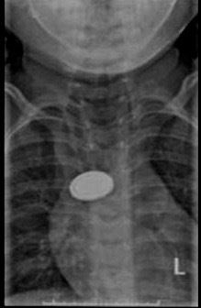

* 1. Button battery in the esophagus***
  2. Coin in the esophagus
  3. Button battery in the trachea
  4. Coin in the trachea
  5. Two coins in the trachea

18) Which common electrolyte and blood pressure abnormalities would be expected in a 4-week-old male with severe congenital adrenal hyperplasia?

A. Hypernatremia, hyperkalemia, hypertension

B. Hyponatremia, hypokalemia, hypotension

C. Hyponatremia, hyperkalemia, hypotension ***

D. Hyponatremia, hyperkalemia, hypertension

E. Hypernatremia, hypokalemia, hypotension

19) An 18-month-old girl presents for a well-child check. She has had a total of 7 separate upper respiratory infections and was hospitalized for RSV once. She is in daycare full-time and her mother is frustrated about the amount of time that she has had to take off from work due to her daughters’ illness. Which of the following is the most appropriate option at this time?

A. Obtain serum immunoglobulin levels

B. Obtain vaccine antibody titers

C. Obtain total hemolytic complement (CH50) assay

D. Obtain nitro blue tetrazolium (NBT) test

E. Reassure the mother *

20) An 8-year-old is evaluated for 2 days of worsening hip pain. He was seen by his pediatrician 5 days ago for low-grade fever and rhinorrhea. His past medical history is unremarkable, and he denies recent trauma. His temperature is 38 degrees Celsius, and his heart rate is 98 beats/minute. What is the most likely cause of his current symptoms?

A. Septic arthritis

B. Osteomyelitis of the hip joint

C. Juvenile idiopathic arthritis

D. Transient synovitis *

E. Myositis

21) The mother of a 6-month-old girl presents for a well-child check. The baby’s weight and length are below 2 standard deviations from mean, which of the following is a true statement regarding failure to thrive in infants?

a. most cases need admission to hospital for work-up

b. extremely rare in the Palestine

c. most often caused by an organic problem

d. It may lead to stunting and short stature ****

22) A13-month-old infant presents to her primary care provider’s office with respiratory distress. The normal respiratory rate of a 13-month-old child is which of the following?

1. between 60 and 80 breaths per minute
2. Up to 60 breaths per minute
3. Up to 50 breaths per minute
4. Up to 40 breaths per minute***

23) One of the characteristics coughs matches with diagnosis

a. Wheezing sinusitis

b. Barking cough Pertussis

c. Paroxysmal cough Croup

d. Nocturnal cough Bronchiolitis

e. Disappear during sleep Habit cough***

24) A 31-week preterm baby presents at 1 week of life with an increased oxygen requirement. The infant has respiratory distress syndrome. Physical examination reveals tachycardia, bounding pulses with wide pulse pressure, and an infra-clavicular systolic murmur. The infant is currently stable on their ventilator settings. Which of the following is the next step in managing this infant's symptoms?

* 1. Prostaglandin infusion
  2. Immediate surgical ligation
  3. Percutaneous occlusion devices
  4. Indomethacin or ibuprofen therapy***
  5. Surfactant administration

25) The most common cause cardiac arrest in pediatric age group is:

a- Renal failure

b- Inborn error of metabolism

c- Liver failure

d- CNS failure

e- Respiratory and circulatory failure***

26) A 3-year-old boy is brought to the clinic with a rash. The parents report that his rash began as red, flat lesions that progressively grew "bumpier" and subsequently broke, developing golden crusting over the past week. On physical examination, he has multiple golden-crusting lesions on his face and arms. Gram staining of the exudate shows gram-positive cocci in chains. Which of the following is the most likely complication of this infection?

* 1. Acute rheumatic fever
  2. Post-streptococcal glomerulonephritis***
  3. Encephalitis
  4. Coronary artery aneurysm
  5. Pneumonia

27) What would be the correct diagnostic investigation for a 5-year-old boy with headache, fever, vomiting, drowsiness and a positive Kernig sign?

a. A CT scan of the brain

b. An ultrasound of the abdomen

c. A lumbar puncture***

d. An ECG

e. An EEG

28) Only one of the following measures is appropriate in the management of a 9-month-old infant suspected of having mild gastroenteritis:

a. Stop breastfeeding or formula feeds until the diarrhea stops

b. Prescribe anti-emetics to control vomiting

c. Prescribe an anti-peristaltic agent to reduce gut motility

d. Prescribe amoxicillin if a stool culture shows a growth of enteropathic E. coli

e. Prescribe oral rehydration therapy (ORT) to ensure adequate hydration***

29) A 4-month-old baby has vomiting precipitated by episodes of severe prolonged coughing with gasping. There is no dehydration and the abdomen is soft. What is the most likely diagnosis?

a. Reflux

b. Pertussis ***

c. Bowel obstruction

d. Asthma

e. Aspirated foreign body

30) An 8-year-old girl attends the clinic with recurrent abdominal pain. Which of the following is most consistent with a functional origin to her symptoms?

a. Nocturnal pain

b. Weight loss

c. Periumbilical pain***

d. Recurrent fever

e. Ill appearance

31) Which is correct relating to ventricular septal defect?

a. Cardiac failure does not occur at birth***

b. Commonly causes central cyanosis

c. Typically has a marked diastolic murmur

d. Surgery is required in most cases

e. Ventricular fibrillation is common

32) In a child of 18 months, the following may be a sign of neurodevelopmental disability:

a. Not walking independently***

b. Only six words with meaning

c. Not talking in sentences

d. Inability to eat with a fork

e. Unable to hop

33) One of the following statements is consistent with a diagnosis of cerebral palsy:

a. Cerebral palsy is a disorder of movement***

b. Hypotonia is the commonest form

c. Cerebral palsy is due to an insult at birth in most cases

d. It is a form of neurodegenerative disorder

34) Which one of the following is a symptom of diabetic hypoglycemia?

a. Shakiness***

b. Polydipsia

c. Polyuria

d. Vomiting

e. Abdominal pain

35) Which of the following genetic conditions is inherited in the mode of inheritance in the following pedigree?

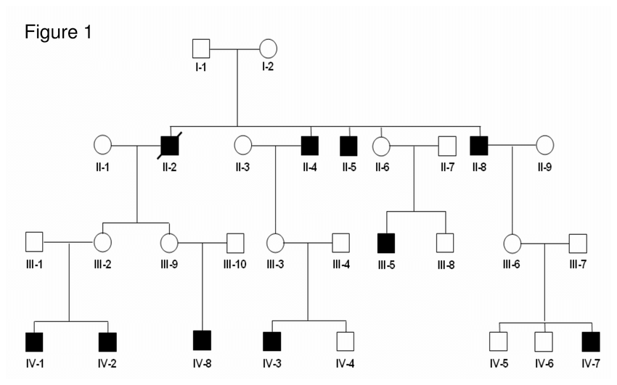

1. Hemophilia B **
2. Rett syndrome.
3. Incontinentia Pigmenti.
4. Marfan syndrome
5. Neurofibromatosis type 1

36) Obese children may experience musculoskeletal problems. Which of the following is classically associated with obesity?

a. Transient synovitis

b. Neoplastic disease affecting the bones

c. Legg-Calve Perthes disease

d. Rupture of the anterior cruciate ligament

e. Slipped capital femoral epiphysis***

37) When would you first expect to see X-ray changes in osteomyelitis?

a. From the onset of the fever

b. 10 days following onset of symptoms ***

c. 3 weeks following onset of symptoms

d. 2 days after onset of symptoms

e. X-rays are not helpful in the diagnosis of osteomyelitis

38) Which one of these findings are suggestive of septic arthritis of the hip?

a. Limited movement of the leg**

b. Narrowing of the joint space on ultrasound

c. Absence of organisms on gram stain of the aspirate

d. Leg held in extension and adduction

e. Nocturnal pain in the knee

39) A well 3-year-old girl complains of severe peri-anal itching at night and early in the morning. She is generally healthy and physical examination is normal. What is the likely cause?

a. Chickenpox

b. Atopic dermatitis

c. Cholestasis

d. Threadworms**

e. Tinea capitis

40) Which sign is compatible with an innocent murmur?

a. Diastolic murmur

b. Absent femoral pulses

c. Hyperactive precordium

d. Fixed split-second sound

e. Ejection systolic murmur at left sternal border ***